**Topics: Normal distribution, Functions of Random Variables**

1. The time required for servicing transmissions is normally distributed with ** = 45 minutes and ** = 8 minutes. The service manager plans to have work begin on the transmission of a customer’s car 10 minutes after the car is dropped off and the customer is told that the car will be ready within 1 hour from drop-off. What is the probability that the service manager cannot meet his commitment?
2. 0.3875
3. 0.2676
4. 0.5
5. 0.6987

answer is B) 0.2676

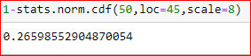

1. The current age (in years) of 400 clerical employees at an insurance claims processing center is normally distributed with mean ** = 38 and Standard deviation ** =6. For each statement below, please specify True/False. If false, briefly explain why.
2. More employees at the processing center are older than 44 than between 38 and 44.

False

44 has an z value of 1. 38 has an z value of 0. 68% values lies between -1 and 1 z

scores. Therefore 34% data points lies between 0 and 1.

32% values lies outside (-1,1). Therefore 16% lies above an z score of 1.

Therefore more employees are between 38 and 44 than above 44.

1. A training program for employees under the age of 30 at the center would be expected to attract about 36 employees.

True



1. If *X1* ~ *N*(μ, σ2) and *X*2 ~ *N*(μ, σ2) are *iid* normal random variables, then what is the difference between 2 *X*1 and *X*1 + *X*2? Discuss both their distributions and parameters.

A)Since X1 and X2 are independent E(X1+X2)=E(X1)+E(X2)

=µ+ µ

=2µ

Since X1 and X2 are independent E(2X1)=2E(X1)=2µ

Variance(X1+X2)=V(X1)+V(X2)+2Cov(X1,X2)

Since X1 and X2 are independent, Cov(X1,X2)=0

Therefore Var(X1+X2)=V(X1)+V(X2)=2 σ2

V(2X1)=22V(X1)

=4V(X1)

=4 σ2

Therefore 2X1 follows a normal distribution with mean 2 µ and variance 4 σ2

And X1+X2 follows a normal distribution with mean 2µ and variance 2 σ2

Therefor X1+X2 ~ N(µ, 2σ2)

and 2X1 ~ N(µ, 4σ2)

1. Let X ~ N(100, 202). Find two values, *a* and *b*, symmetric about the mean, such that the probability of the random variable taking a value between them is 0.99.
2. 90.5, 105.9
3. 80.2, 119.8
4. 22, 78
5. 48.5, 151.5
6. 90.1, 109.9

Answer is D)48.5,151.5.

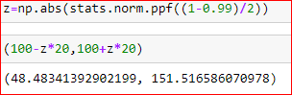

1. Consider a company that has two different divisions. The annual profits from the two divisions are independent and have distributions Profit1 ~ N(5, 32) and Profit2 ~ N(7, 42) respectively. Both the profits are in $ Million. Answer the following questions about the total profit of the company in Rupees. Assume that $1 = Rs. 45
2. Specify a Rupee range (centered on the mean) such that it contains 95% probability for the annual profit of the company.
3. Specify the 5th percentile of profit (in Rupees) for the company
4. Which of the two divisions has a larger probability of making a loss in a given year?

Answer

A)Since the profits of 2 are independent, Profit1+Profit2 ~ N(5+7,32+42)

Profit1+Profit2  ~ N(12,25)

Therefore the new Profit distribution mean = 12

standard deviation=250.5=5

95% of the the values lies between the z values(-1.6,1.6)

Therefor 95% of the values lies between (2.20 , 21.80)

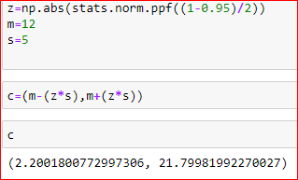

B)The 5th percentile value of the company = 3.78



C)For the first division the chance of loss=4.78%

For the 2nd division, the chance of loss=4.01%

Therefor the first division has a higher chance of making profit.

